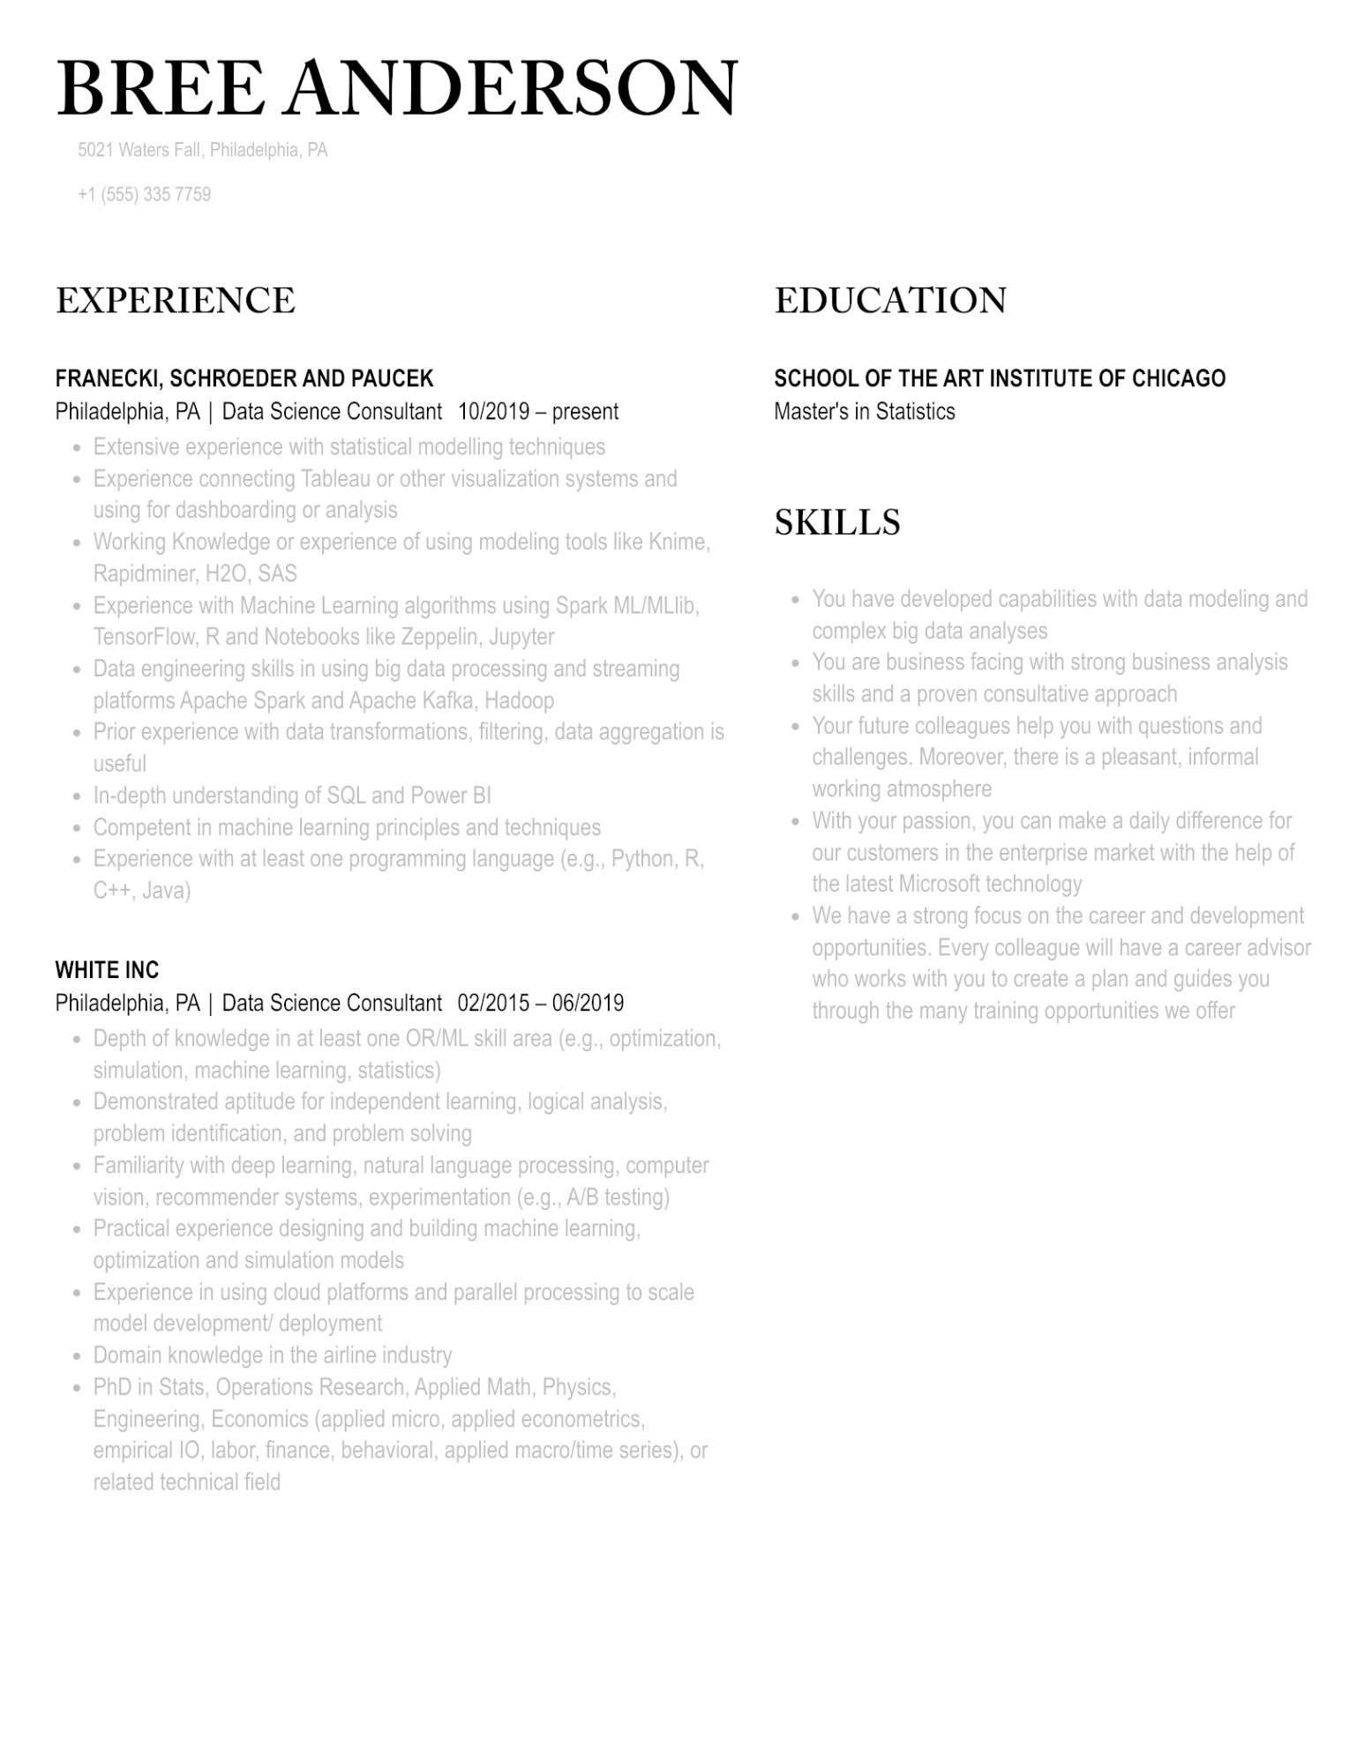
BREE ANDERSON
5021 Waters Fall, Philadelphia, PA
+1 (555) 335 7759
EXPERIENCE
FRANECKI, SCHROEDER AND PAUCEK
Philadelphia, PA | Data Science Consultant 10/2019 - present
•
•
•
•
•
•
•
•
Extensive experience with statistical modelling techniques
Experience connecting Tableau or other visualization systems and using for dashboarding or analysis
Working Knowledge or experience of using modeling tools like Knime, Rapidminer, H2O, SAS
Experience with Machine Learning algorithms using Spark ML/MLlib, TensorFlow, R and Notebooks like Zeppelin, Jupyter
Data engineering skills in using big data processing and streaming platforms Apache Spark and Apache Kafka, Hadoop
Prior experience with data transformations, filtering, data aggregation is useful
In-depth understanding of SQL and Power BI
Competent in machine learning principles and techniques
Experience with at least one programming language (e.g., Python, R, C++, Java)
WHITE INC
Philadelphia, PA | Data Science Consultant 02/2015 - 06/2019
•
•
•
•
•
Depth of knowledge in at least one OR/ML skill area (e.g., optimization, simulation, machine learning, statistics)
Demonstrated aptitude for independent learning, logical analysis,
problem identification, and problem solving
Familiarity with deep learning, natural language processing, computer
vision, recommender systems, experimentation (e.g., A/B testing)
Practical experience designing and building machine learning,
optimization and simulation models
Experience in using cloud platforms and parallel processing to scale
model development/ deployment
Domain knowledge in the airline industry
PhD in Stats, Operations Research, Applied Math, Physics,
Engineering, Economics (applied micro, applied econometrics,
empirical IO, labor, finance, behavioral, applied macro/time series), or related technical field
EDUCATION
SCHOOL OF THE ART INSTITUTE OF CHICAGO Master's in Statistics
SKILLS
•
•
You have developed capabilities with data modeling and complex big data analyses
You are business facing with strong business analysis skills and a proven consultative approach
Your future colleagues help you with questions and challenges. Moreover, there is a pleasant, informal working atmosphere
With your passion, you can make a daily difference for our customers in the enterprise market with the help of the latest Microsoft technology
• We have a strong focus on the career and development opportunities. Every colleague will have a career advisor who works with you to create a plan and guides you through the many training opportunities we offer

